<https://www.dreamstime.com/print-image146622236>

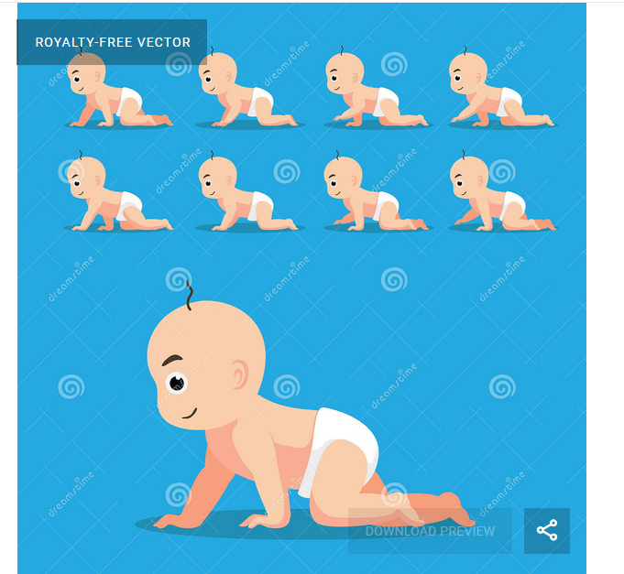



ID 146622236 © Punnawich Limparungpatanakij | Dreamstime.com